**Phase 6: User Interface Development**

Goal: Make it user-friendly.

1. **Lightning App Builder**
   * A boutique App is created with the Lightning Web Component for the handling of various tasks and customers in a small business.

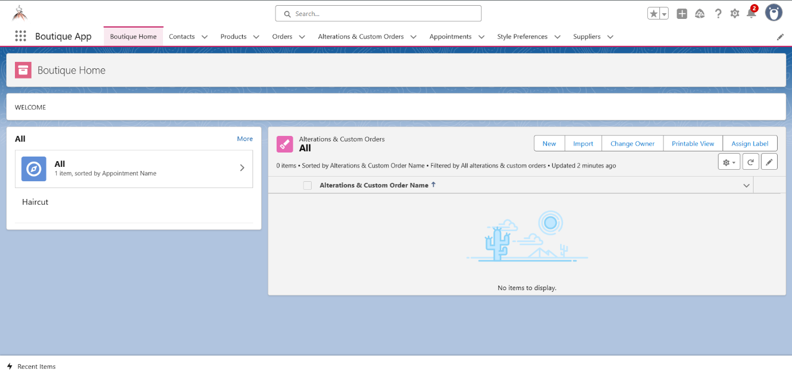

1. **Tabs**
   * Various tabs for the custom objects are added in the app for seamless use by the owner.

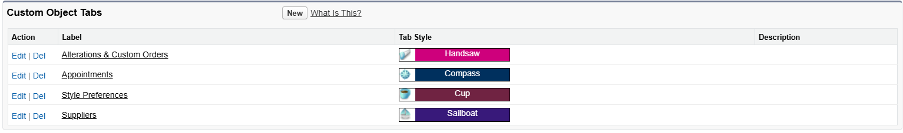

1. **Apex with LWC**
   * Apex is used with lightning web component in integration with vs code for the better use of the application.

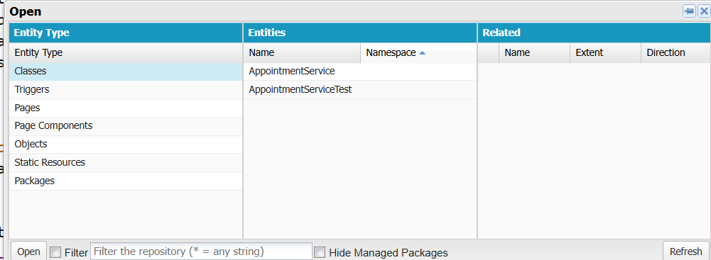

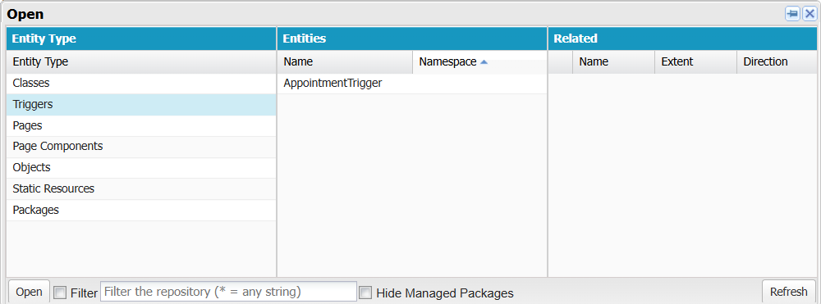

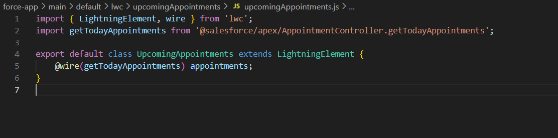

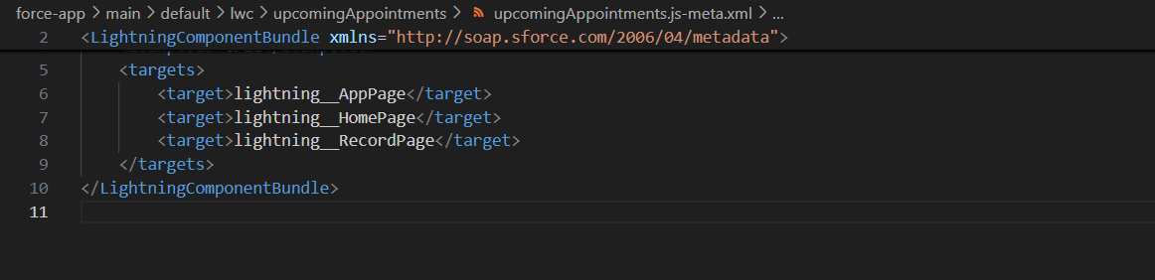

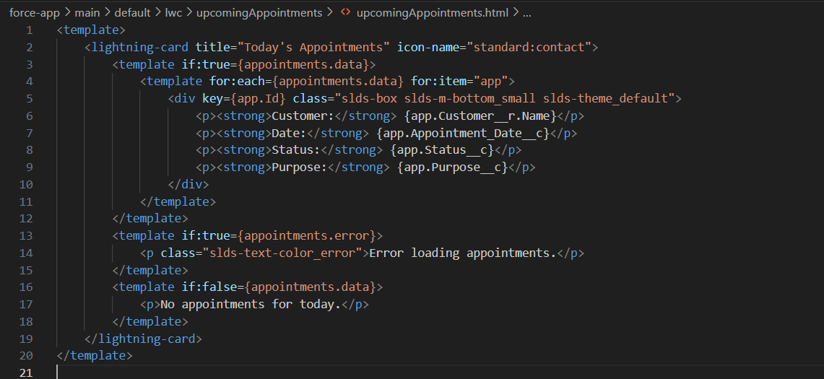

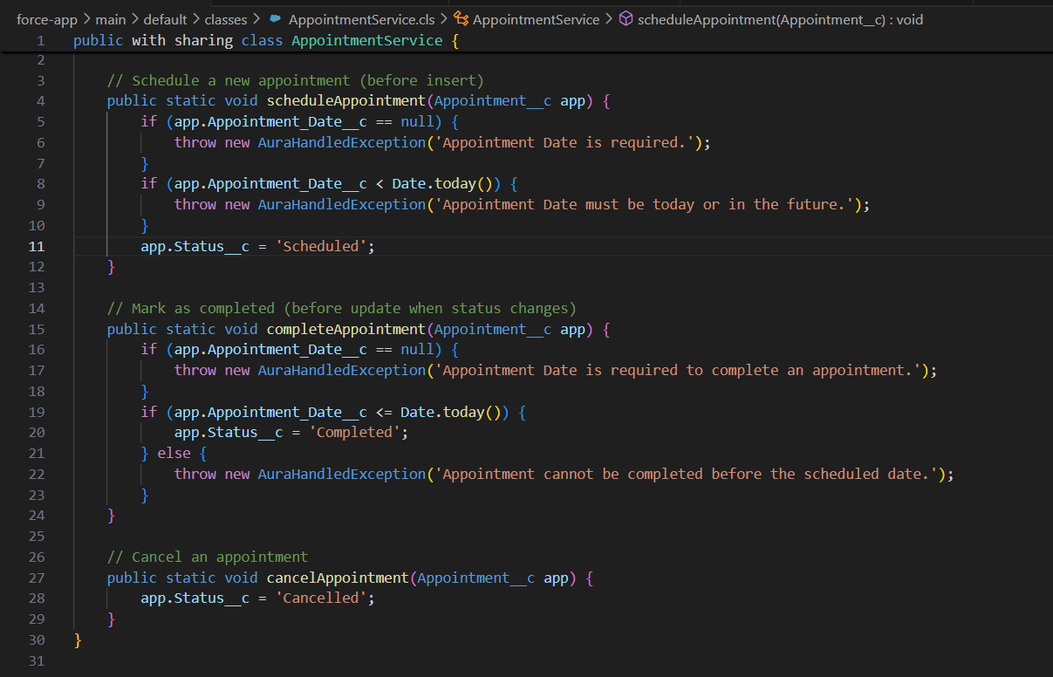

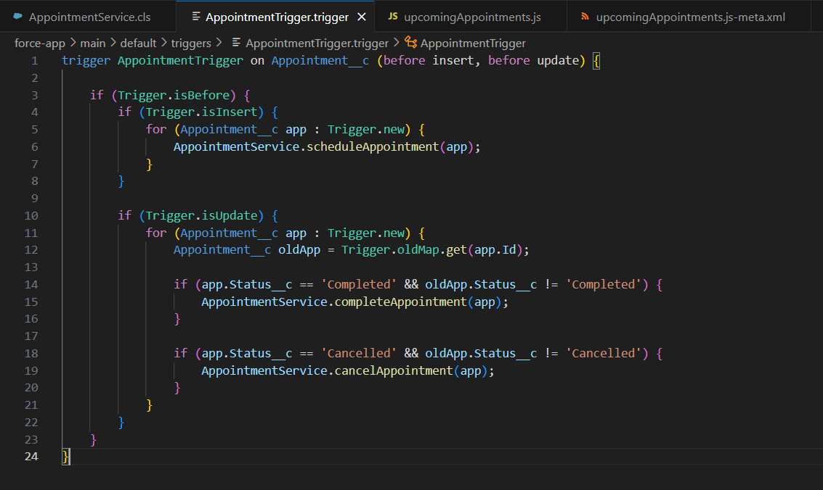

1. **Utility Bar**
   * Quick ‘Recent Items’ action for easy access by the owner.

